Instructions:

* Replace the highlighted areas in yellow above with your own name, section and group numbers and correct dates,
* Watch lab demo video and review related materials in lecture notes, lab manual and other related documents,
* Provide your best answers to the following questions. Add pages as needed,
* Convert this Word worksheet sheet into pdf format and submit to Canvas.

**1.** (30 points) For specimens I and II (Table 1 below), derive an expression for the area moment of inertia *I* about its neutral axis in terms of h, b and t.

**2.** (25pts) Calculate the theoretical shear center of each of the five specimens using the following expressions as derived on pages 9 and 11 in lecture notes:



C-channel:



Circular open-channel:

See Fig. 1 for all the corresponding parameters *h, b, t, r* and *0*. Note that the total opening angle is 2*0*. Hint: to derive the expression for *I* for specimens I and II, you can do one of two ways: (1) calculate *I* for the horizontal flanges and vertical web individually and then sum up or (2) use “subtraction” method by calculating *I* for a larger “outer” rectangular area and then subtracting it from *I* of the smaller “inner” area. You will also need parallel axis theorem. Also, as indicated in Fig. 1, the shear center offset *e* for the C-channel beams is measured from the center of the vertical web, while *e* for the circular open-channel pipes is measured from the center of circular cross section. Likewise, height h is measured between mid-planes of top and bottom flanges, and r is mean radius, i.e. r=(OD-t)/2.

**3.** (5 pts) tabulate the results.

Total 60 points

Table 1. Dimensions for the two types of cross sections of specimens

|  |  |  |  |  |  |  |
| --- | --- | --- | --- | --- | --- | --- |
| Specimen ID | Cross  section  type | Height  h  (inch) | Width  b  (inch) | Thickness  t  (inch) | Outer diameter OD (inch) | Opening angle 2  (degree) |
| I | Plastic C-channel | 2.43 | 1.456 | 0.08 | NA | NA |
| II | Metal C-channel | 0.84 | 0.56 | 0.055 | NA | NA |
| III | PVC circular open | NA | NA | 0.071 | 1.66 | 3.1 |
| IV | PVC circular open | NA | NA | 0.071 | 1.66 | 36.3 |
| V | PVC circular open | NA | NA | 0.071 | 1.66 | 103.7 |

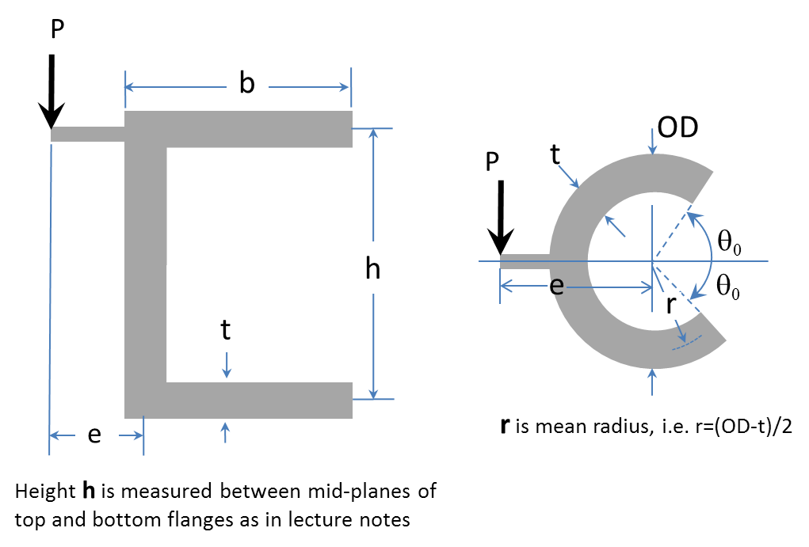

Figure 1. Schematic diagrams of the thin-walled cross section of specimen: (left) C-channel and (right) circular open channel

Answers:

1 & 2:

3:

|  |  |
| --- | --- |
| Specimen ID | Theoretical shear center (in) |
| I | 0.5816 |
| II | 0.2323 |
| III | 1.5884 |
| IV | 1.5253 |
| V | 1.2654 |